Week 4 AQ/PQ

Q1. What is the following HTML code is correctly represented by the DOM structure below?
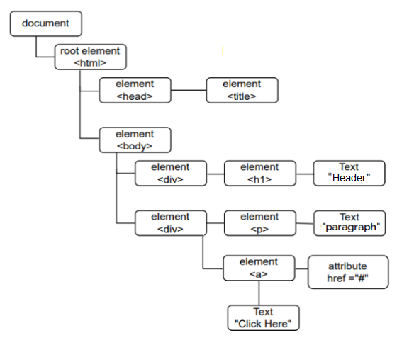

A.
<html>
<head>
<title>My website</title>
</head>
<body>
<div>
<h1> Header </h1>
<p><a href="#"> Click Here </a></p>
</div>
</body>
</html>

B.
<html>
<head>
<title>My website</title>
</head>
<body>
<div>
<h1> Header </h1>
</div>
<div>
<p> <a href="#"> Click Here </a> </p>
</div>
</body>
</html>

C.
<html>
<head>
<title>My website</title>
</head>
<body>
<div>
<h1> Header </h1>
</div>
<div>
<p>Paragraph</p>
<a href="#"> Click Here </a>
</div>
</body>
</html>
D.
<html>
<head>
<title>My website</title>
</head>
<body>
<h1> Header </h1>
<p><a href="#"> Click Here </a></p>
</body>
</html>

Answer: C

Lecture AQ.4.4

Q1. Which of the following would change the default templates folder to "views" in a Flask app?

app = Flask(__name__, template= "views")

app = Flask(__name__, templates= "views")

app = Flask(__name__, template_folder= "views")

app = Flask(__name__, templates_folder= "views")

Answer: C

Q2: In which of the following options, url_for() function calls will produce URL http://localhost:5000/home?

@app.route('/home')
def index():
return "This is Homepage content"
@app.route('/')
def homepage():
return redirect(url_for(index))

@app.route('/home')
def index():
return "This is Homepage content"
@app.route('/')
def homepage():
return redirect(url_for('index'))

@app.route('/home')
def index():
return "This is Homepage content"
@app.route('/')
def homepage():
return redirect(url_for('/home'))

@app.route('/home')
def index():
return "This is Homepage content"
@app.route('/')
def homepage():
return redirect(url_for('home'))
Answer: Option B

Practice Assignment 4

Q1. Consider the following flask application and select the correct option if the application is running locally on http://127.0.0.1:5000.
[MCQ: 2 points]

from flask import Flask
app = Flask(__name__)
@app.route('/home')
@app.route('/work')
def my_task():
return "<h1>Hello! Reporting for my task</h1>"
app.run()

- The application will return 200 OK status code for /work endpoint only
- The application will return 404 PAGE NOT FOUND status code for /home
endpoint only
- The application will throw an AssertionError for both the endpoints
- The application will return 200 OK status code for both the endpoints

Answer: D

Q2. Consider the following flask app. Given that test_request_context() allows text to be printed on the terminal, which of the following statements is/are correct?

[MSQ: 4.5 points]

from flask import Flask, url_for
app = Flask(__name__)
@app.route('/home')
def index():
return 'Mad-I welcomes you!'
@app.route('/user/<username>')
def profile(username):
return f'{username}\'s profile'
with app.test_request_context():
#== print statement ==#

- If #== print statement ==# is replaced by print(url_for('index')),
the output on the terminal will be /home.

- If #== print statement ==# is replaced by print(url_for('profile', username='Harry')), the output on the terminal will be /user?username=Harry

- If #== print statement ==# is replaced by print(url_for('profile', username='Harry', next='course')), the output on the terminal will be /user/Harry/course

- If #== print statement ==# is replaced by print(url_for('index', username='Harry')), the output on the terminal will be /home?username=Harry

Answer: A and D

Q3. Consider the following code.
[MCQ: 3 points]
from flask import Flask
app = Flask(__name__)
@app.route('/')
def generate1():
return "This is generate1"
@app.route('//')
def generate2():
return "This is generate2"
@app.errorhandler(404)
def page_not_found(e):
# setting 404 status explicitly
return 'page not found'
app.run()
If the flask application is running on http://127.0.0.1:5000, what will browser render for URL http://127.0.0.1:5000//

- Page not found
- This is generate1
- This is generate2
- Code will throw error

Answer: B

Q4. Consider the following view function.
[MCQ: 2 points]

@app.route('/employee', methods = ['GET', 'POST'])
def show_details():
det = request.args
details = {
'Department': det['dept'],
'Id': det['id'],
'Profession': det['prof']
}
return details

If this flask app is running locally on http://127.0.0.1:5000, which of the following URLs will be handled by the controller correctly ?

http://127.0.0.1:5000/employee/Electrical/IC101/Analyst

http://127.0.0.1:5000/employee?dept=Electrical&id=IC101&prof=Analyst

http://127.0.0.1:5000/Electrical/IC101/Analyst

http://127.0.0.1:5000?endpoint=employee&dept=Electrical&id=IC101&prof=Analyst

Answer: B

